What next? A modest proposal

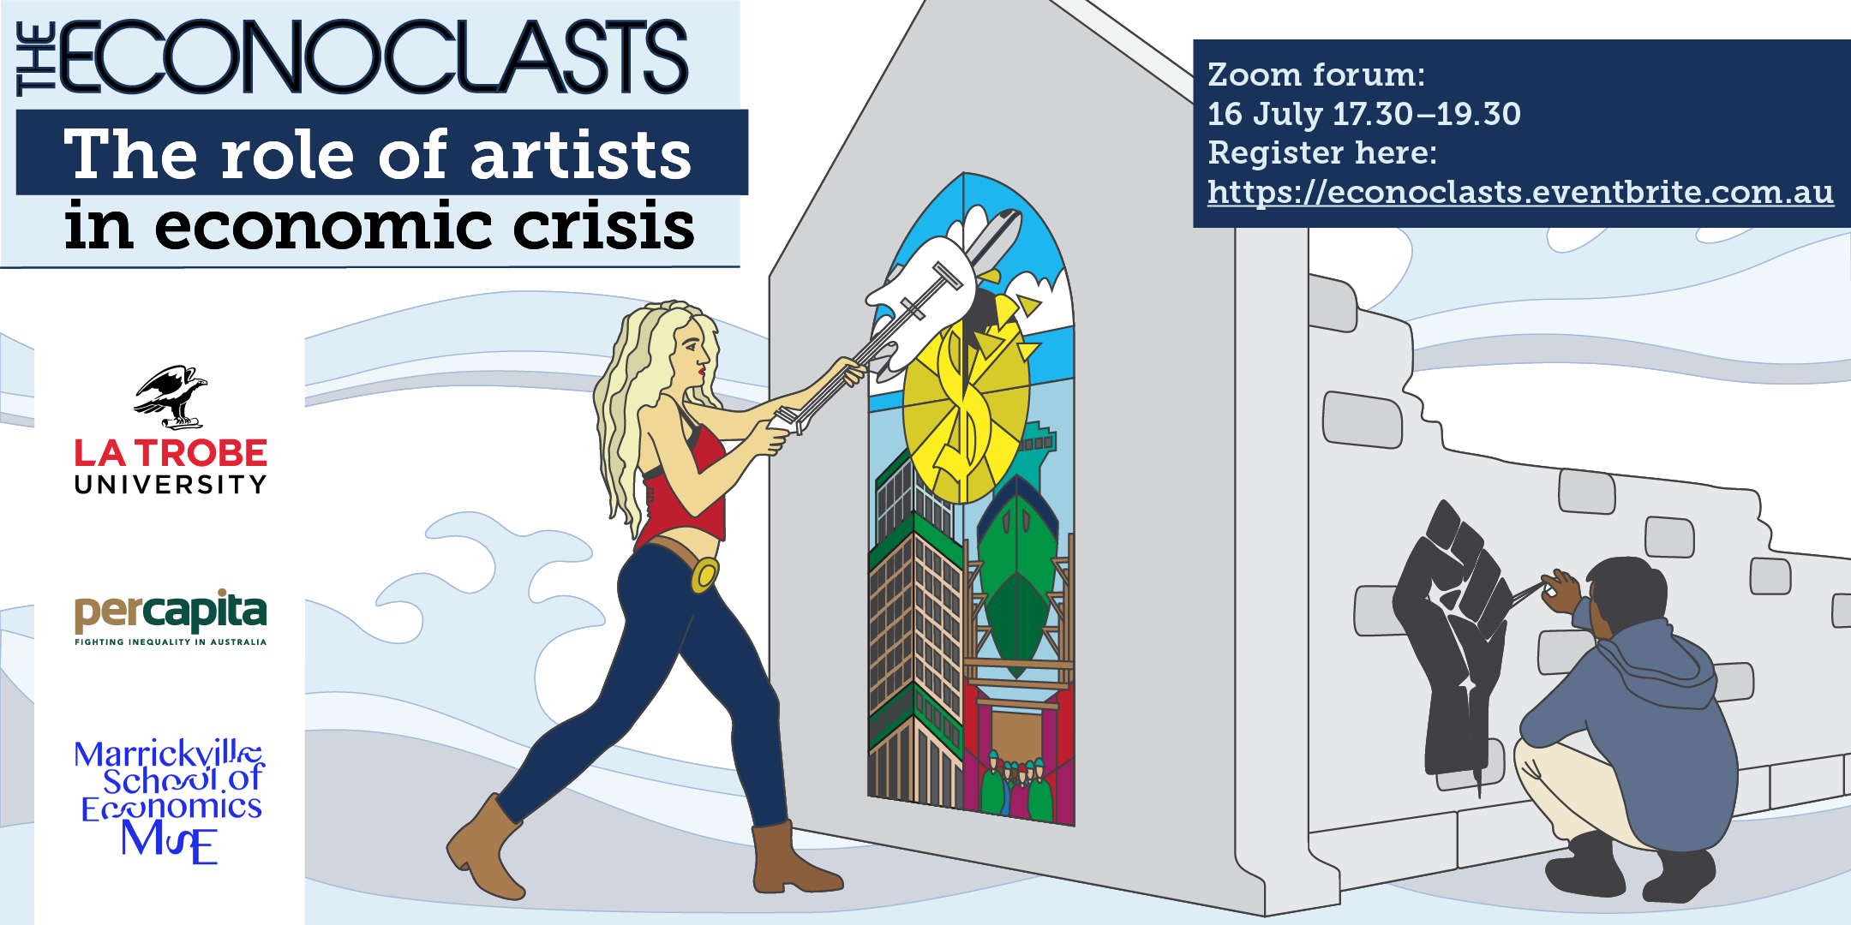

What if….

Hundreds of artists across Australia united to use our wits and various crafts to debunk a central tenant of neoliberal economic eg ‘austerity’ – ie that the Federal govt ‘cannot afford’ to invest in socially productive assets and keep citizens above the poverty line?

Eg

- Musicians from chamber orchestras write a ‘2020 Defence Budget’ oratario ‘celebrating’ the fact that the Federal government has commited $270bn to missles and bombs but could only scrape up $250m to the arts (mostly loans via banks)
- Verbatim theate groups around the country dramatise the reality of unemployed people in their communities looking for work when there aren’t any jobs and trying to live on below poverty line Newstart levels (pre-Jobseeker boost)
- Street artists and mural workers produce comic strips in public places that illustrate why government debt is completely different to household debt
- Filmmakers make short darkly humous ‘infotainment’ videos and memes about the bogus ‘science’ of austerity economics
- Photographers and fashion designers combine to dress artists in high-viz ‘tradie’ gear and ‘tradies’ as artists, swapping their tools of trade eg hammers and paintbrushes, take arresting photos with the caption ‘Let me fix our economy’.

A simple website (and FB page – meh – but necessary?) could be created that would explain the (neo-Keynesian, Green new deal) reasoning and necessity behind the Econoclasts movement, provide a central repository for all works produced and a conduit for media enquiries. What d’ya reckon?

